z ⁻¹ (9 + 6 z ⁻¹ + 6 z ⁻²) z ⁻¹ (9 + 6 z ⁻¹ + 6z ⁻²)
G(z) = ----------------------------------------- = -----------------------------------------
(1 – 0.8 z ⁻¹) (1 – 0.68 z ⁻¹) (1 – 0.5z ⁻¹) 1 – 1.98z ⁻¹ + 1.284 z ⁻² + 0.272z ⁻³
For this project, I used the same transfer function as in projects 1 and 2. This transfer function defines the plant used throughout this project.
Question 1: Drive the Plant with a Random Input
To create a zero-mean unit random input, I utilized the ‘randn’ function from MATLAB. The randn function returns a scalar of random values drawn with a normal distribution and unit-variance. After this, the output was obtained via simulation by utilizing the lsim command in MATLAB. The code that does this is shown below.
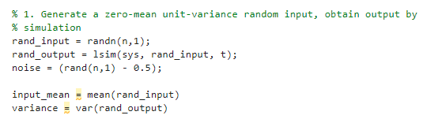
The output of the mean of the input and variance of the input & output are shown below.
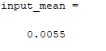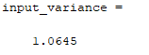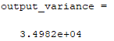
The generated input and simulated output are shown below.

Question 2: Add Zero-Mean Noise
With the system simulated with a zero-mean unit-variance random input, I created zero-mean independent random noise. The standard deviations of the noise were 0.01, 0.03 and 0.10 times the standard deviation of the output respectively. To most accurately do this, I used a control noise signal to change the magnitude of the other three noise signals to accurately get the standard deviations of the noise signals to meet parameters. The code that does this is shown below.
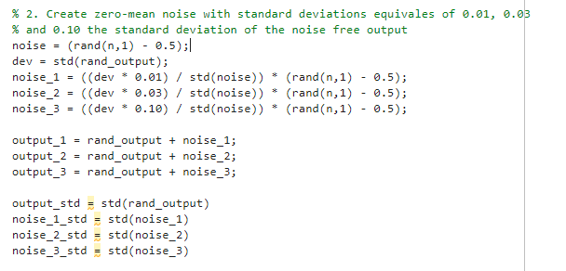
The standard deviation of the output of the system and the three noise signals is listed below.
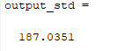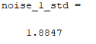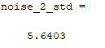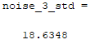
The noise signals are graphed below.
With this done, I had three noise signals each independent of the input and the other noise signals.

Question 3: Recursive Data Collection Least-Squares Estimation
The next step was to write a recursive-data collection least squares estimation algorithm to identify the system parameters under each noise condition. The system generated 2000 samples to identify the parameters of the system. The code for the recursive data collection least squares estimation function is shown below.
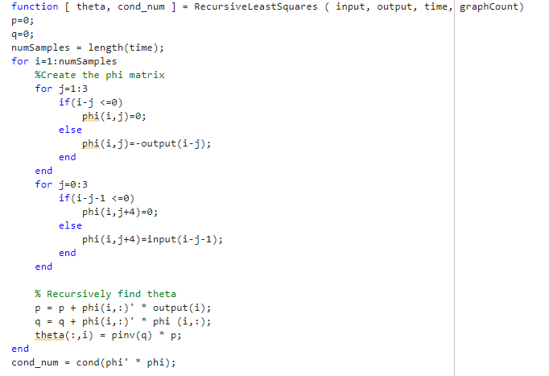
The code that uses this function and executes the code from the main program is shown below. The code runs with the noise free output and the three noisy outputs based on the random inputs.
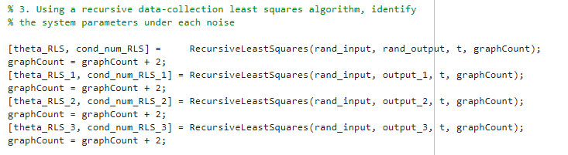
For each one of these function calls, there are two graphs generated, to show samples 1-100 and 1900-2000. Below is graphed estimation for the noise-free output.
Here we can see that the estimation quickly converges to the correct values of the parameters and stays converged throughout the entire simulation. The final estimation of this function is shown below and can be seen to be correct to the system parameters. The condition number of this estimation is 4.1e6 which is within acceptable range of the parameters.
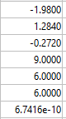

Below is the graph for the parameter estimation for the 0.01x noise signal added to the output.
Here we can see that the parameters converge over time to a consistent estimation. However, that estimation is not entirely correct due to the added noise in the system. The condition number of the final estimation matrix is 1.25e6 which is within acceptable ranges. The final estimation is shown below where we can see the effect of the noise has caused many of the numerator’s parameters to be larger than anticipated and the denominator’s parameters to be close, but not accurate to what is expected.
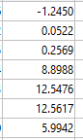
Next is the estimation for the output with a noise of 0.03x the standard deviation of the noise free output.
We can see that the initial estimation is affected by the noise even more, as the convergence of the parameters takes more time than in previous examples. Additionally, we can see that the final estimation is even less accurate from the correct estimation. This is showing again the effect of the noise on the system and how the additional noise has decreased the estimation for the denominator parameters and increased the estimation for the numerator parameters. Below, we can see the final estimation of the parameters for this simulation. The condition number for this final estimation was 3.17e5 which is within parameters.
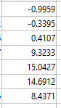

Finally, we have the estimation for the output with an added noise of 0.10x the standard deviation of the noise-free output.
Once again, it can be seen how the noise is affecting the estimation of parameters. The estimation takes an increasing amount of time to converge, and the final estimation is even more inaccurate. The estimation for the numerator parameters has gotten even larger while the denominator parameters have gotten slightly smaller. This is again an effect of the noise added to this system. The final estimation can be seen below. The condition number for this estimation is 1.6e5, which is within acceptable ranges.
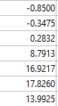
Overall, with this method of parameter estimation, we are able to get relatively accurately estimates at first, with the noise-free output and the 0.01x noise output. However, with the larger noise, the estimation begins to become more and more inaccurate to the expected parameters.

Question 4: Recursive Least Squares with Forgetting Factor
With the recursive least squares algorithm giving estimations of each of the parameters, I next wrote a separate algorithm to do a recursive LS estimation with a forgetting factor. The code for this algorithm is shown below.
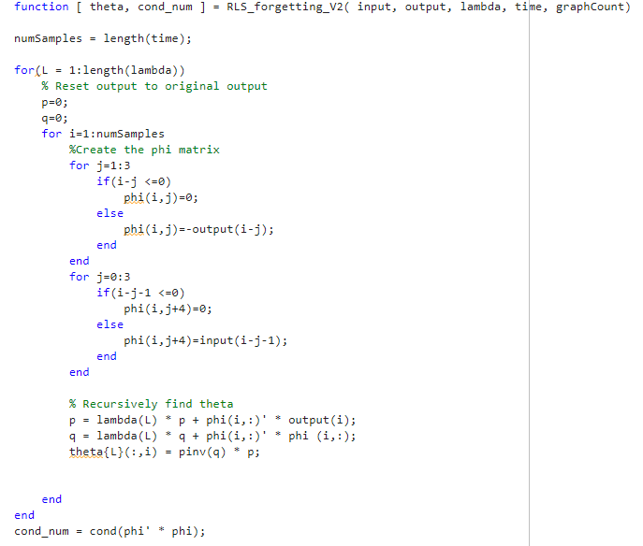
This function is able to recursively estimate the parameters given the input, output, lambda, and time. The code in the main program that leverages this function is shown below.
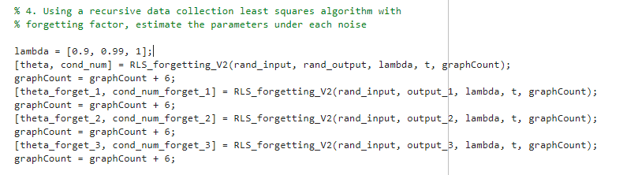
The estimations are graphed from samples 0-100 and 1900-2000 as requested. The estimations are made for the noise-free output and the noisy outputs. Below are the estimations for the noise free output for each lambda value.
For each lambda value, with the noise free output, we can see that the estimation of parameters converge quickly and remain steady state throughout the 2000 samples. We can see that the estimated parameters are very accurate to the expected values for all lambda values. The final estimations for each lambda value are shown below (in the order of 0.9, 0.99 and 1).
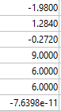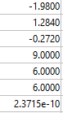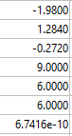

Below are the estimations for the parameters with the noisy signal of 0.01x for each lambda value.
For these estimations the lambda value seems to have a strong effect on the final estimations. As the forgetting factor decreases, the estimations become more susceptible to the effects of noise. When lambda is 0.9, the never converge on and are fairly erratic in their estimations, whereas when lambda is 1 the parameters converge, even if they’re still inaccurate. The final estimations for each lambda value are shown below (in the order of 0.9, 0.99 and 1).

0.9 0.99 1
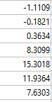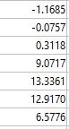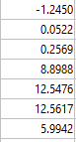
Below are the estimations for the parameters with the signal that has the noise of 0.03x the standard deviation of the output added to it.
Similar to the previous estimations, we can see how a lower lambda value causes erratic behavior in the final estimation and with noise of this magnitude, the estimation never truly converges on a single value. With a higher lambda value, the parameters converge entirely, even if the noise has affected the numeric value of the converged parameters giving an inaccurate estimation. The final estimations for each lambda value are shown below (in the order of 0.9, 0.99 and 1).
0.9 0.99 1
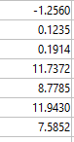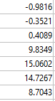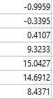

Below are the estimations for the parameters with the signal that has the noise of 0.10x the standard deviation of the output added to it.
Again, we see the effect of the noise causing the estimations to be more inaccurate when compared to the expected values. Additionally, the lower the lambda value again causes the parameters to never truly converge due to the noise in the system. The final estimations for each lambda value are shown below (in the order of 0.9, 0.99 and 1).

0.9 0.99 1
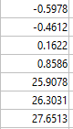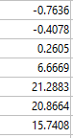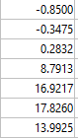

Question 5: Unbiased Method
With the recursive methods shown above estimating the parameters for each noise level, an unbiased method was next used from the Matlab Toolbox. Following the recommendation, I chose to use the IV4 method from the Matlab Toolbox. The code to create the data object and estimate the parameters in the system is shown below.
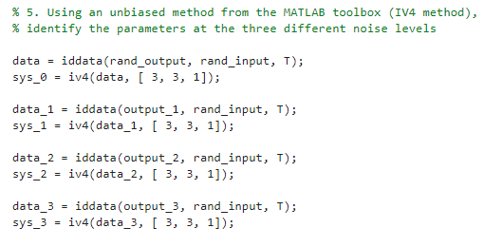
The iv4 function returns an idpoly object, and the parameters for each estimation are held in the A and B matrices. Below are the estimations for the nose free system and the noisy systems, in increasing levels of noise.
Noise Free: 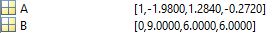
Noise 0.01x 
Noise 0.03x 
Noise 0.10x 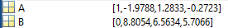
When using the iv4 method from the Matlab toolbox, we can see that the estimated parameters stay accurate to the expected value despite the noise. While there certainly is some changing of the final estimation due to the noise, the iv4 estimation stay considerably more accurate than the recursive algorithms written in questions 3 and 4 of this assignment. Overall, the iv4 method was significantly more accurate in estimating the parameters as the noise of the system increased.

